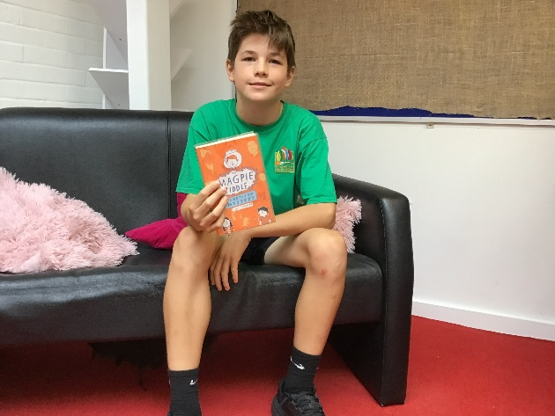
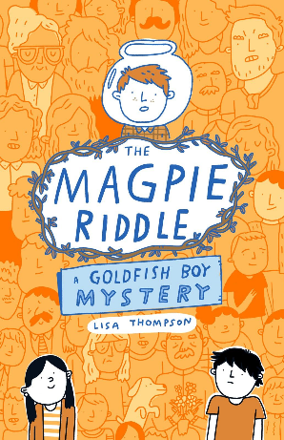
We are starting the term off with a book review each fortnight! Today, it is Huey in Year 6 and he explains why 'The Magpie Riddle- Goldfish Boy Mystery' is his recommended read.
Book Review
I really enjoyed this book because it was full of interesting events and unique characters. The main character is especially unique because they enjoy visiting graveyards, which is not something many people like to do!
I would definitely recommend this book to children in Years 4, 5 and 6 because it is engaging, thought-provoking and full of fascinating details - like the plague!
My rating: 4.5 out of 5 stars! ½

