Foxhills Federation Year 6 Residential Trip
PGL Osmington Bay
8th – 12th June 2026

Information for Parents

IMPORTANT NOTE:
If your child cannot attend the trip at the last minute (or on morning of departure), please contact the school office.

PGL Osmington Bay, South Devon information:
Osmington Bay Centre,
Shortlake Ln,
Osmington,
Weymouth
DT3 6EG
Important Information

Travel sickness tablets:
Children who suffer from travel sickness should please be provided with appropriate travel sickness medicine. If in doubt,
please give your child travel sickness tablets just in case! It would help if tablets had already been taken on Monday morning
and supplied for the departure day (clearly labelled with the child’s name and handed to a member of staff on arrival at
school).

Medicines:
Please ensure any medicines are clearly marked with name and dosage. Medicine will be collected by staff on Monday
morning at school, and administered as directed throughout the week. Please give medicines in their original boxes. Please
collect a form to fill out before arrival on the Monday. These will be available Monday morning if needed.

Food:
Children need a packed lunch, snacks and drinks in their day bag for the journey. In addition to this, you may wish to give us a snack (for example: a packet of cereal bars or individually wrapped cakes) to put into our ‘snack pool’. Please remember to check that the items do not include nuts. We ask that you do not provide snacks for children to have in their rooms. This keeps things fair and safe for the children.

If you have any questions about your child’s food requirements, please let us know.

For information regarding food during the week, please visit the following link for an example menu: https://schoolsandgroups.pgl.co.uk/uk-pgl-menu/

Electronics & Phones:
The centre will not allow any electronic games, and children may not bring their mobile phone due to safeguarding reasons, and to prevent possible homesickness. Please be reassured that the teachers attending will contact parents during the visit if we need to. Bringing a digital or disposable camera is a good idea- please ensure that it is clearly labelled.

Cosmetics and Jewellery:
Please ensure that no spray aerosols are taken on the trip as these can set off the fire alarms in rooms and trigger asthma in other pupils. No make-up or jewellery should be taken on this trip.

Rucksack: Rucksack should contain: a packed lunch for the first day in a disposable bag, a refillable water bottle, lightweight wet-weather gear, sunhat, sunglasses and sun cream.

Pocket Money:
Please supply your child with a maximum of £10 in a wallet or envelope clearly marked with their name. There is a PGL gift shop which your child will visit during our stay.

Return Packing List:
Include check-off packing list for your child to use before returning. (A good idea is to tape it inside the suitcase lid).

Birthdays: If your child’s birthday is during the week, please let us know.

Queries & Worries Before the Trip:
Ring to talk to a Year 6 Teacher at Foxhills Junior School: 023 8029 2126.

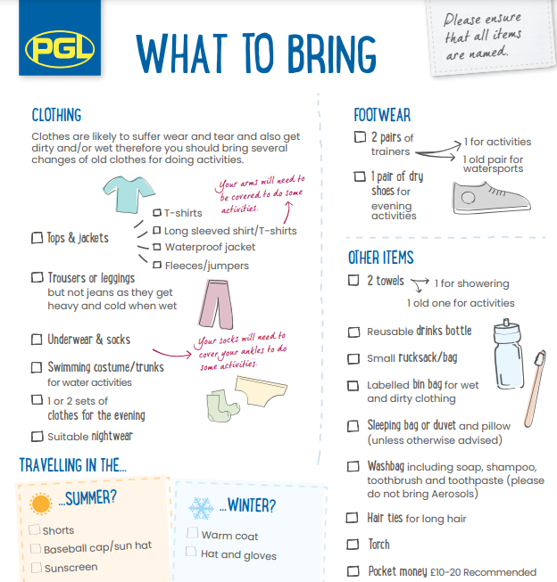

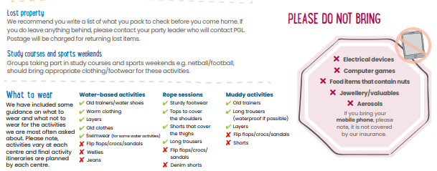
£10 maximum

