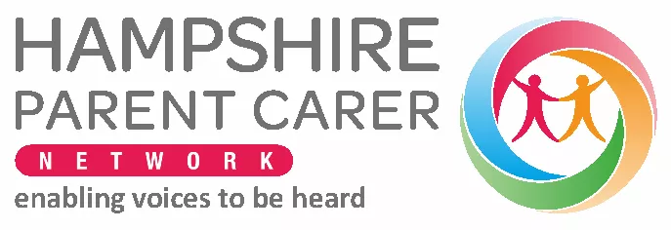

The Parent Carer Survey to support the Partnership for Inclusion of Neurodiversity in Schools (PINS) project.

Dear Parents and Carers,
We would like your help in completing a survey about our school and your child please.
Our school is participating in the national PINS project -Partnership for Inclusion of Neurodiversity In Schools (PINS). NHS England is funding the project, working with the Departments of Education, Health and Social Care, and the National Network of Parent Carer Forums (NNPCF).
We want to explore how we can collaborate to be more inclusive of all children, improve the experience of children who may have additional needs, and work more closely with you as parent carers. To do that, we want to know where we are starting today so that we can work together as we go on a journey to become even better. The information from the survey will be used to understand the current strengths and potential areas of improvement in a school.
The survey is for all parents and carers of children attending schools participating in the project. If you have more than one child attending the school, then you may complete the survey for each child you have attending the school.
Please follow below or scan the QR code to complete the survey:

https://www.surveymonkey.com/r/HPCNPINS

A thematic summary of the survey results will be shared with your participating school and PINS project partners from NHS England, Department of Education and NNPCF to help us plan our support going forward.
If you have any questions, please let us know.
Best wishes,
Paul Richardson Chair HPCN

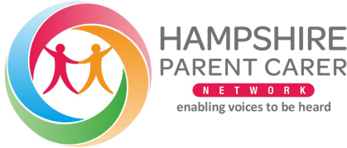
Who are HPCN?
- HPCN - Hampshire parent carer network are the formal department of education local Parent Carer Forum for SEND (Special Educational Needs and Disabilities).
- HPCN works with Hampshire County Council, and Hampshire ICB to coproduce and improve services for SEND across Hampshire.
- We offer free support groups, information, professionally supported workshops and events.
- Future In Mind (FIM) program, puts people who are waiting for either diagnosis or clinical help from CAMHS, in workshops and support groups with CAMHS professionals now, rather than waiting years.
- Bridging the GAP (BTG) program works with parents and carers of young people aged 14-25 who are going through a mental health transition, to Inform and make the transition smoother.
- Parent Led & Meet the SEND events, gives parent and carers access to SEND teams and management to ask questions to those that they might find harder to access.
- We work across Hampshire, linking parents and carers to the right professionals.
- We work to make sure you get the services you need in a way that works for you by feeding back to those who are responsible for them.
Find out more about us and the free support we offer: www.HPCN.org.uk

If you have any questions or concerns, please feel free to contact us at pins@hpcn.org.uk

